We have 3 RabbitMQ in a cluster (rabbitmq-01, rabbitmq-02, rabbitmq-03)   
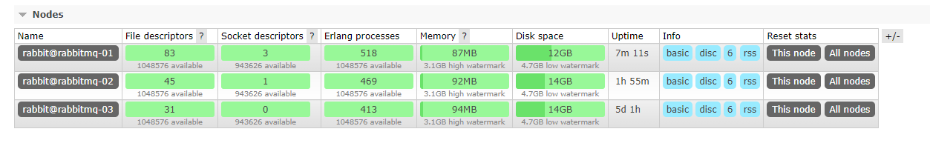  
The services can connect to the rabbit without any issue and receive and send messages  
using MassTransit , the issue is when we test the failover between RabbitMQ cluster nodes   
we connected to rabbitmq-01  
  
  
when we “kill” rabbitmq-01 we see that the services are connected to rabbitmq-02  
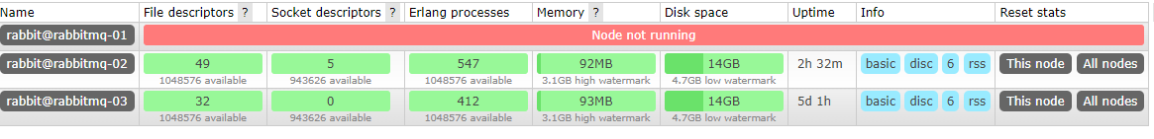  
the producer service is connected only when we send a new message and the consumer service is connected but without any channels  
  
  
consumer connection  
